
Mehran University of Engineering and Technology Jamshoro
ASSIGNMENT : LAB 09
SUBJECT : PROGRAMMING FUNDAMENTALS
ROLL NO : 24BSAI29
SUBMITTED BY : SYED MUHAMMAD QASIM
SUBMITTED TO : MA’AM FAHAMA BARKZAI

Department of Software Engineering
Mehran University of Engineering and Technology, Jamshoro

Course: AI-112 – Programming Fundamentals
Instructor | Engr. Fahama Barakzai | Practical/Lab No. | 09
Date |  | CLOs | 3
Signature |  | Assessment Score | 01 Mark

Topic | Working with Arrays
Objectives | - To become familiar with basic concepts of Arrays.  - To work with Single dimensional and Multi-dimensional arrays.

Lab Discussion: Theoretical concepts and Procedural steps
TOOLS: TURBOO C++/ DEV C++/ VS-CODE/ CODE BLOCKS

Lab Tasks

- Rebuild a C++ code that takes a value at runtime and searches it in the array. If the value appears in the array, then it prints the position of the value or else prints a message that value is not found.
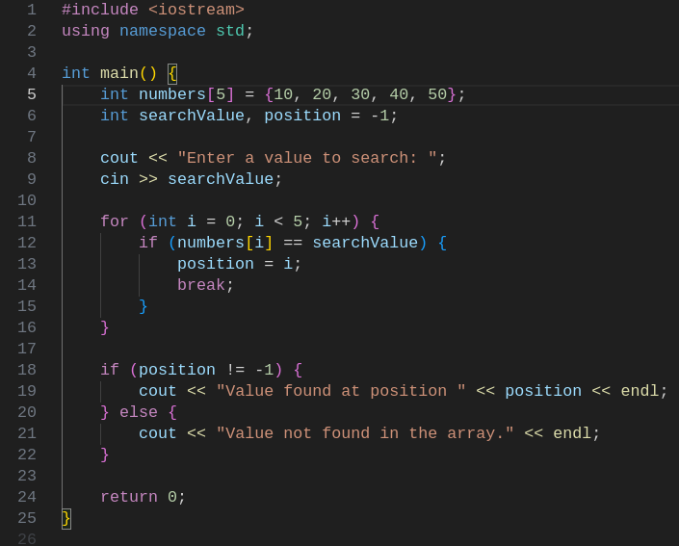

OUTPUT OF THE PROGRAM IS :

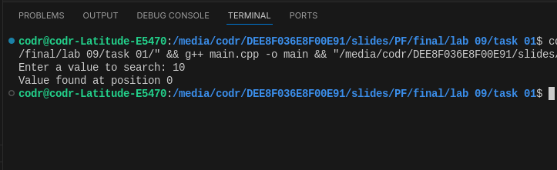
- Rebuild a C++ program that takes 5 floating numbers at runtime and stores them in an array and print their total sum and average.
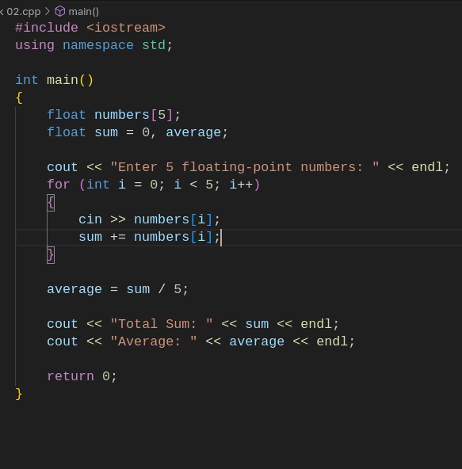

OUTPUT OF THE PROGRAM IS :
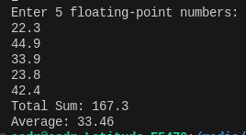

3) Try a C++ program that sorts an array of integers in ascending order.

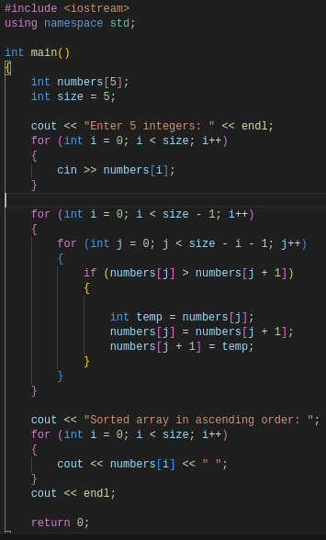

OUTPUT OF THE PROGRAM IS :

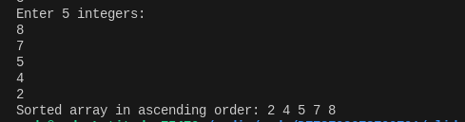
4) Consider the following integer array of size 10.
int array[10]={1,2,3,5,8,10,12,23,28,15};
Try a C++ program that finds and prints all odd numbers in the given array.

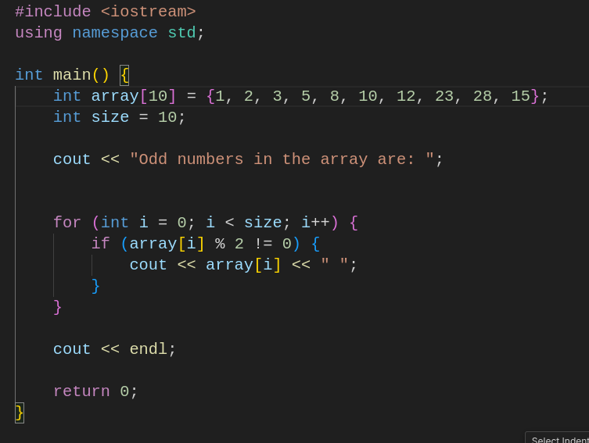

OUTPUT OF THE PROGRAM IS :

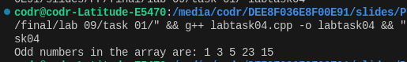

5) Practice a C++ program that finds the smallest element in the array and also its index.

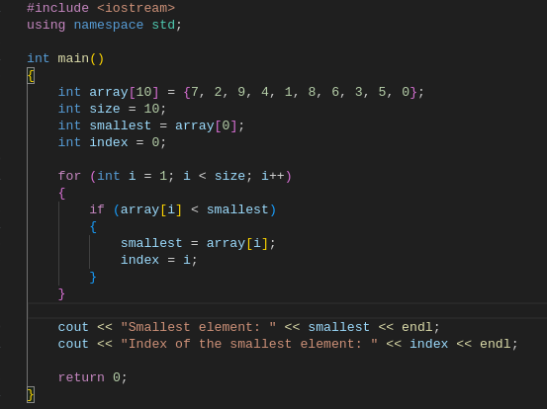

OUTPUT OF THE PROGRAM IS :
